- The recent strength of the pound is more a reflection of dollar weakness than a favourable reassessment of the UK's economic fundamentals, in our view. Some signals suggest the appreciation is overdone and the pound is vulnerable to a depreciation.
- Our current forecast projects that the pound will hold steady against the dollar in a 1.33-1.34 range, as we expect the recent weak-dollar narrative will extend into next year.
- But the UK's challenging fiscal position has kept markets volatile in recent months, and the upcoming Budget could provide a catalyst for sterling to reprice if the government is unable to convince investors that its plans will restore the public finances to a sustainable path.
- While there is scope for large moves in currency markets, by itself a repricing would have a relatively small bearing on the UK's growth prospects. But it would likely prompt policymakers to adjust fiscal policy, which could have a more substantial impact on the economic outlook.
Since launching AskOE – our AI assistant that clients can use to interrogate our data and research banks – earlier this year, one question has cropped up regularly: Can the pound's strength be sustained and what might cause it to reverse?
On a trade-weighted basis, the pound's move has been relatively small over the last year or so. But looking at currency moves since the middle of last year shows several moving parts under the hood. On one side, the path of Eurozone inflation back to target and stabilised market expectations of Eurozone performance has increased investment flows into the single market, weighing on the pound against the euro. On the other, since early-2025 the pound has strengthened against the dollar (Chart 1).
So, the question on sterling's recent performance boils down to: Can the pound sustain its strength against the dollar, particularly given the fiscal challenges the UK faces? Sterling's sharp depreciation after weak public finance data in August only serves to illustrate the currency's sensitivity to the fiscal outlook.
Chart 1: Sterling's performance has been mixed over the last year
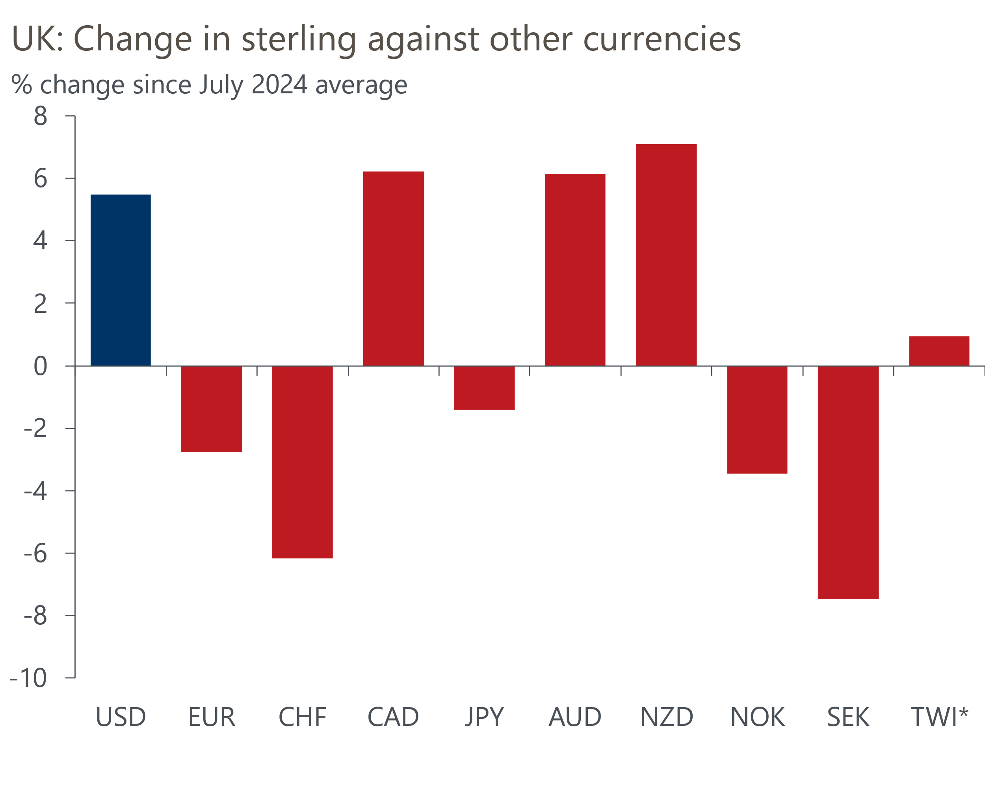
Sources: Oxford Economics, Haver Analytics, *TWI = trade-weighted sterling

Improved UK fundamentals are not the cause of pound strength against the dollar
Since the end of January, real market interest rates in the UK have risen more quickly than in either the US or Europe, with the 10-year real gilt spread to US Treasuries rising by more than 100bps and to German Bunds by more than 40bps (Chart 2). On the face of it, the markets' reappraisal of UK interest rates should have been positive for the currency across the board. But the rise in real rates does not reflect a more bullish outlook for the UK economy's real growth. Rather it reflects the prospect of a higher path for short-rates in the next few years to return inflation to target, and it is investors demanding a greater return for holding UK government debt amid growing concerns over the sustainability of the UK's fiscal position.
Consequently, the pound's performance has been a mixed bag, with the policy shift by the new US administration also affecting currency markets over the last few months. Indeed, since July 2024, when the US presidential race kicked off in earnest after Vice President Kamala Harris took up the Democratic nomination, the pound has strengthened against the dollar. But it has weakened against the euro, yen, and Nordic currencies.
Chart 2: Real rates have increased more in the UK than in other major economies
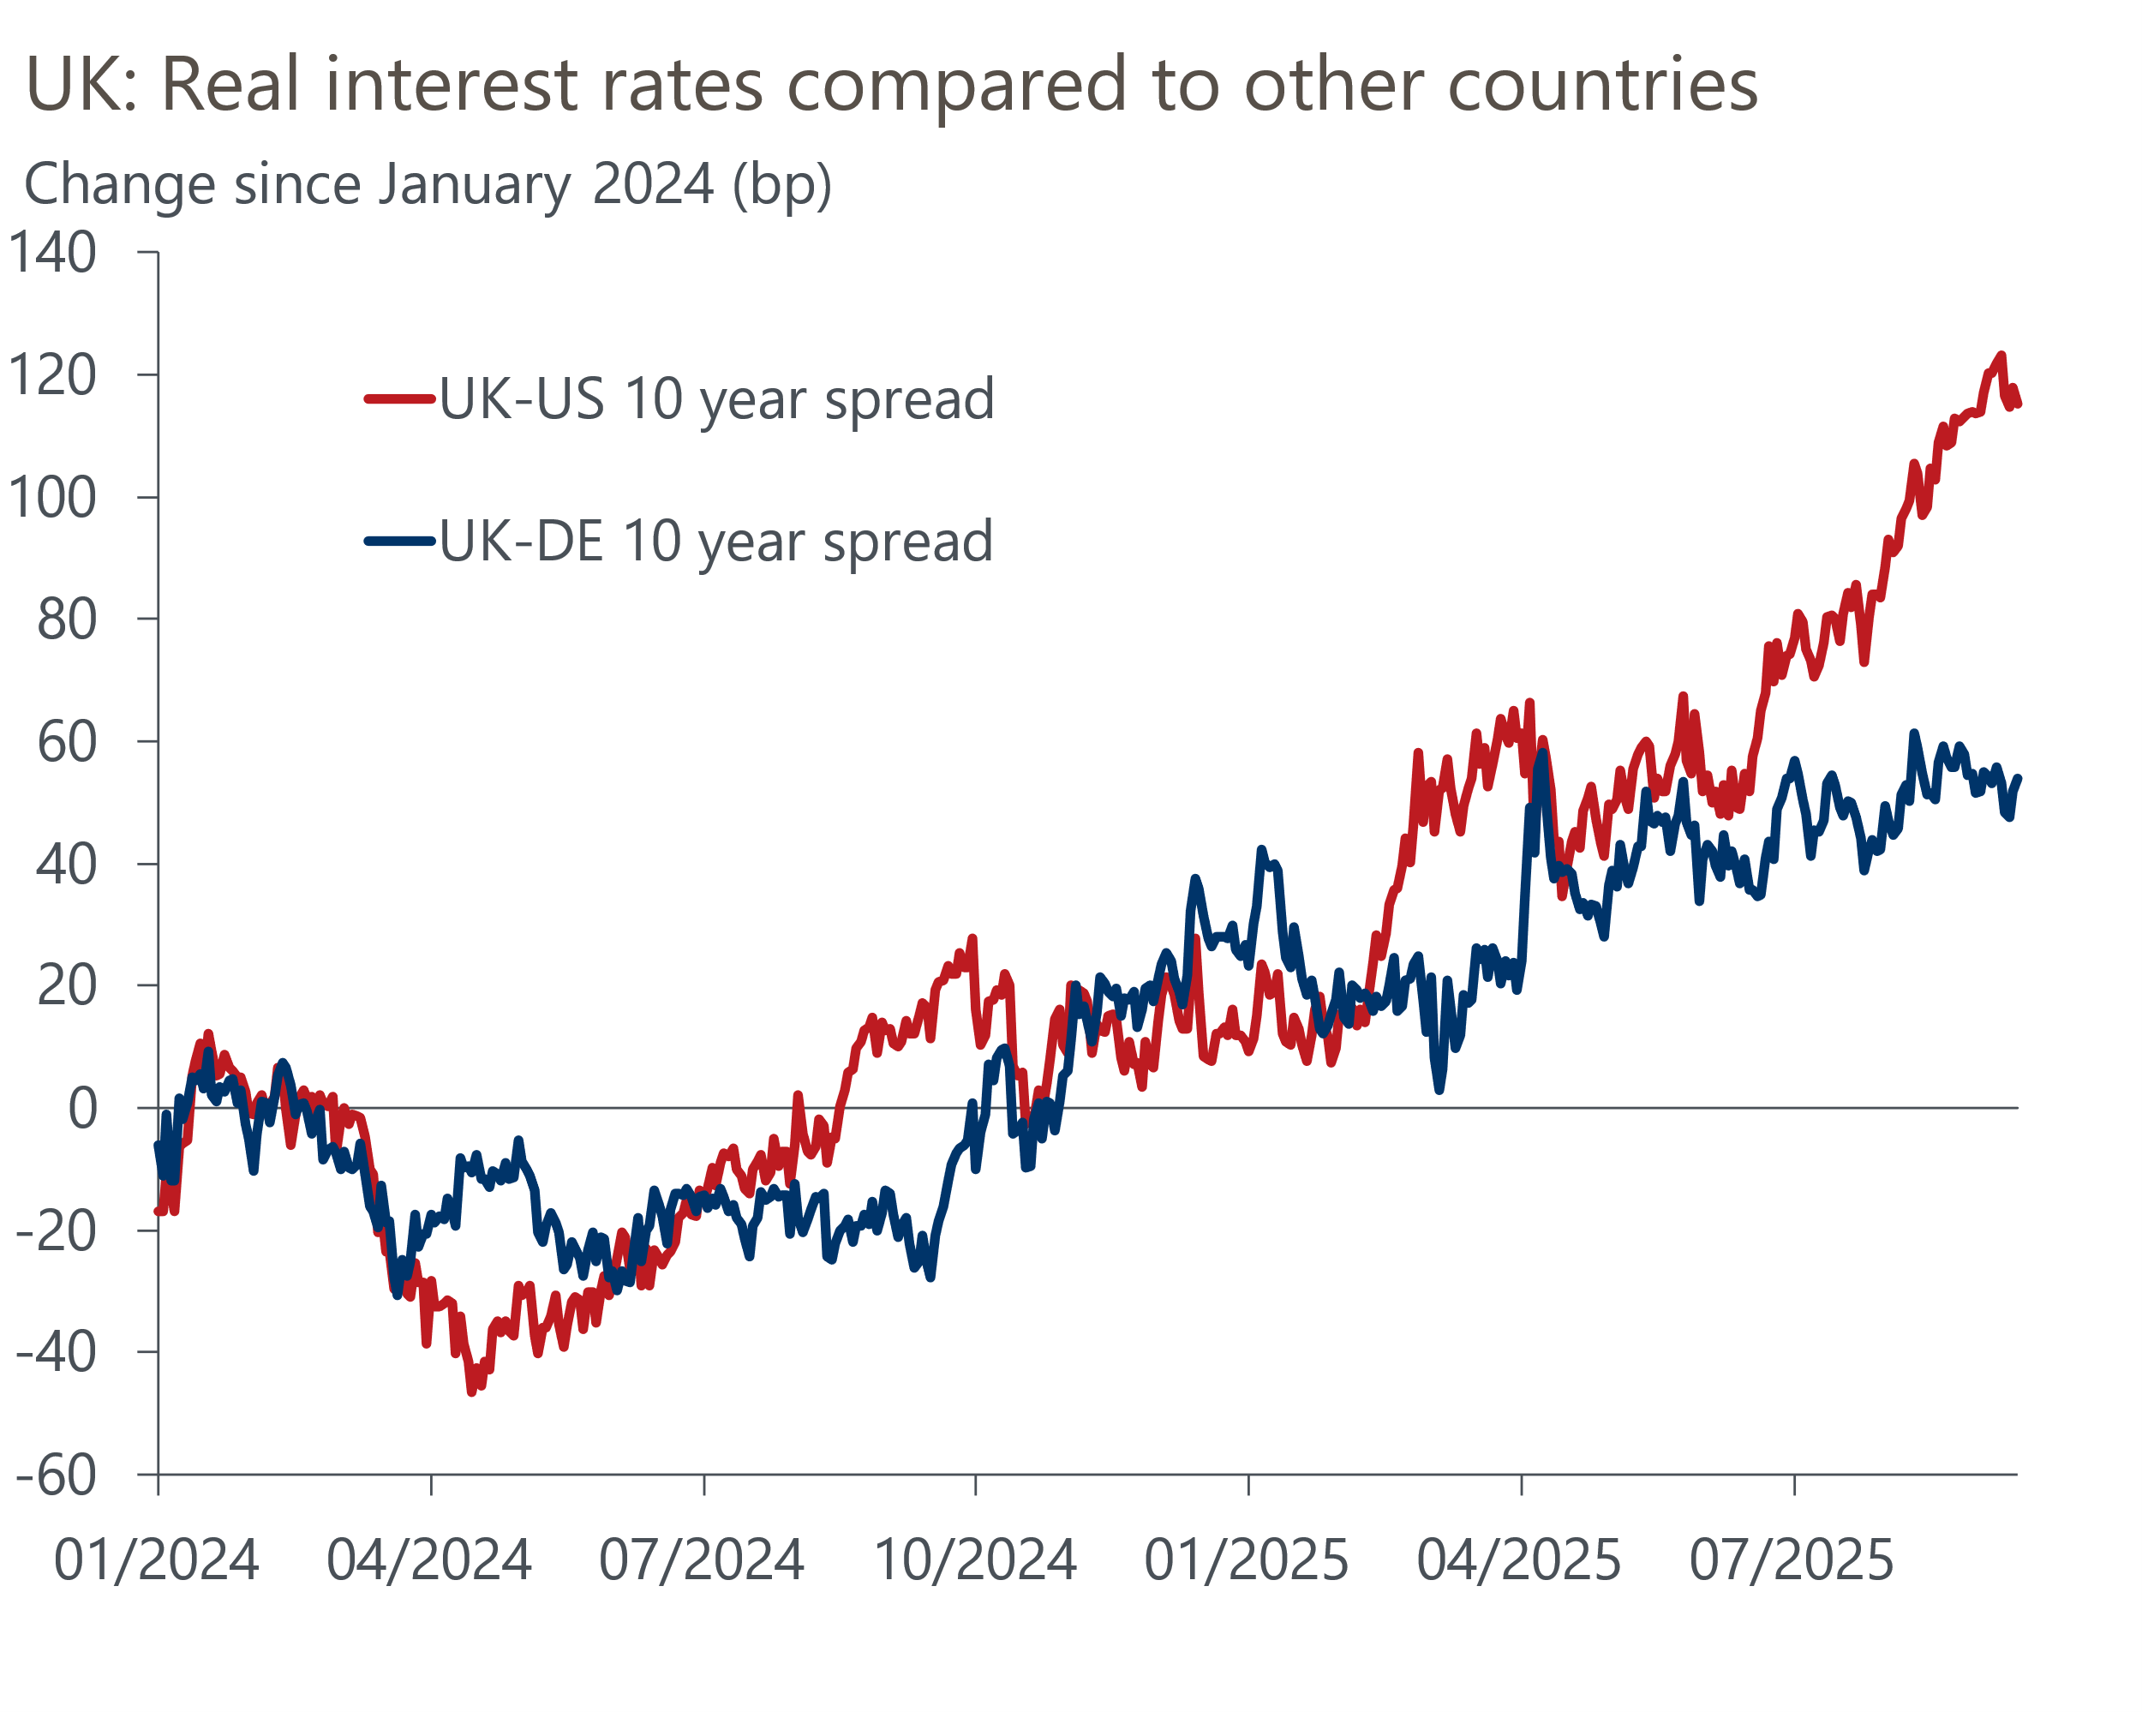
Sources: Oxford Economics, Haver Analytics
In our view, the recent strength of the pound against the dollar is more a story of US weakness than UK strength. On a trade-weighted basis, the dollar fell by more than 6% between its January high and August – catalysed by the US administrations' 'liberation day' tariff announcements on April 2. Since then, the tariff schedule has been relaxed, but it still points to a notable rise in the effective tariff rate to 16.7%.
However, we doubt the Trump administrations' trade policy will be successful in reducing the US current account deficit as it does not address the fundamental imbalance between saving and investment. We expect the US current account to remain in a 3%-4% of GDP range over the coming years. But ultimately it is the change in, rather than the level of, the US basic balance that matters the most for the dollar exchange rate, which we expect to deteriorate to -4% of GDP over the next few years from -1%. So the dollar will have to remain weak to attract short-term capital inflows to cover the shortfall.

The UK's fiscal challenges could reveal sterling's vulnerability
Our central forecast projects that GBP/USD will remain between 1.33 and 1.34 over the next couple of years as we expect the structural factors underpinning the dollar's recent weakness to persist. However, with the UK's fiscal position becoming ever more challenging, the risks to our central case are skewed towards a weaker sterling-dollar, with the possibility of a sharp correction if the government is not able to persuade financial markets that it is able to achieve a clear and sustainable fiscal adjustment. To some extent, the recent rise in term-premia already reflects markets' growing concerns that rising public debt will eventually need to be inflated away.
As it stands, the pound is currently maintaining a valuation of around $1.35 – the strongest it's been since Boris Johnson was prime minister in 2022. However, our strategy team's suite of long-term FX models suggest sterling is trading meaningfully above fair value against the dollar. The team's proprietary behavioural equilibrium exchange rate model framework points to an overvaluation of more than 10% (Chart 3). This raises the question: What could be a catalyst for any correction?
Chart 3: Our BEER model suggests that sterling is more than 10% overvalued against the dollar
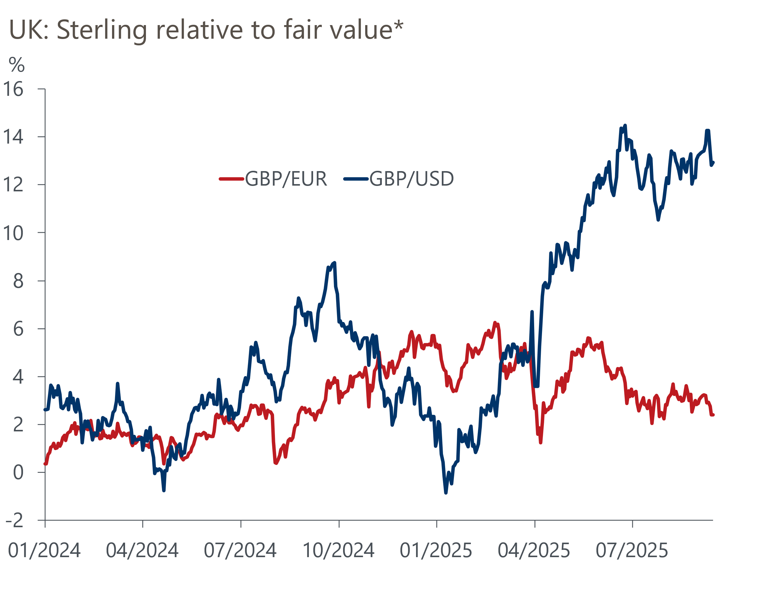
Sources: Oxford Economics, Haver Analytics, *Fair value based on Oxford Economics BEER model
The most obvious candidate is a November Budget that fails to convince the markets that the public finances will be kept on a sustainable footing. We will examine this scenario in more detail in future research. But recent history tells us that if markets are not satisfied, they will move out of UK government debt and shun UK risky assets, potentially putting significant downward pressure on the exchange rate.

Two cases studies with different drivers both result in weaker sterling
Recent episodes of fiscal concern have led to both bonds and sterling selling off, although the underlying reasons for the price drops have differed (Chart 4). In both instances, however, the price action has been brief, with most of the move unwinding after a couple of weeks.
Mini-Budget 2022. The clearest reaction to a UK fiscal policy error is the 2022 mini-Budget. Following her appointment, Prime Minister Liz Truss set out updated fiscal plans that were modelled around significant and unfunded tax cuts. She also sidelined the Office for Budget Responsibility and sacked the Permanent Secretary to the Treasury. Markets rejected the plans on the grounds that they lacked consideration for the long-term sustainability of the public finances.
In response, the UK saw demand for its debt drop sharply, with UK yields rising dramatically compared to other advanced economies. Combined with an evaporation in demand for other UK assets, sterling dropped sharply against the dollar and other currency pairs. The effect of the fiscal announcement on gilt yields was magnified by liability-driven investment (LDI) pension funds having to sell gilts to cover margin calls – analysis by the Bank of England estimates the LDI fire sale explained about half of the drop in UK bond prices. However, this amplification mechanism has subsequently been dampened by regulatory changes.
On a trade-weighted basis, the pound dropped to its lowest level since the 2016 referendum on EU membership. Although that in part reflects its relatively low starting point, there were still sizable shifts in the pound's value with it falling by 4.6% against the dollar and 2.8% against the euro, respectively. However, these moves were short-lived and within two to three weeks had largely reversed.
January 2025. A second notable period of fiscal concern was at the turn of this year. This time, it was an international rather than UK-specific worry that spooked financial markets, with gilt yields rising broadly in line with the US and by only a little more than in Germany.
Still, as a small open economy that operates government and current account deficits, the UK's currency is exposed to global shifts in government debt issuance and international demand for safe assets. So as fiscal fears mounted, sterling depreciated against the dollar and the euro, falling by around 2% against each at its January trough.
Chart 4: Both UK-specific and international concerns have pushed up yields
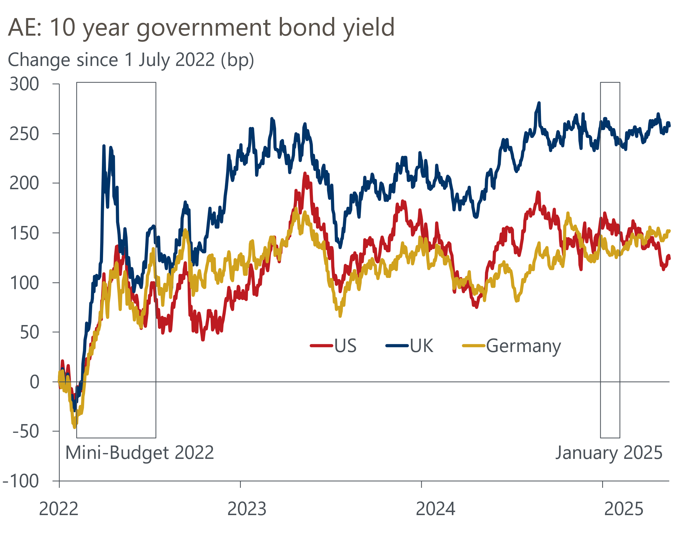
Sources: Oxford Economics, Haver Analytics

A hit to the currency would have a stagflationary effect on the outlook
If the pound were to come under pressure, then the impact on the sterling-dollar exchange rate could be quite large, generating additional inflation with little growth.
As our strategy colleagues have noted, given the UK's challenging fiscal backdrop there is a risk that GBP/USD falls into a 1.25-1.30 range, which would be around a 5% depreciation compared to our baseline forecast. While this would be quite a large shift in the dollar, it wouldn't take it back to a particularly low level; rather it would only reverse the increase we've seen over 2025. The exchange rate averaged 1.28 over 2024.
By itself a depreciation would support growth, as the boost from more price competitive exports would outweigh the impact that higher import prices would have on inflation and real incomes. But in the event of fiscal concerns driving a sterling depreciation, it would be accompanied by higher bond yields as investors shun UK debt. If the move in bond yields was of similar size to January 2025, then analysis using our Global Economic Model indicates that the tightening in financial conditions could offset any potential growth benefit, with little impact on the import-driven boost to inflation. The net effect would leave the UK government having to deal with a slightly more stagflationary backdrop. We will look at a more detailed scenario for the Budget in an upcoming note.
However, market conditions that have entailed a marked rise in gilt yields and a significant currency depreciation have been uncommon (Chart 5). Indeed, these market events, such as the case studies we examined above, have typically led to either interventions or changes in conditions that have caused the large price moves to retrace within a couple of weeks.
Chart 5: Large increases in gilts yields accompanied by a depreciation have been relatively uncommon
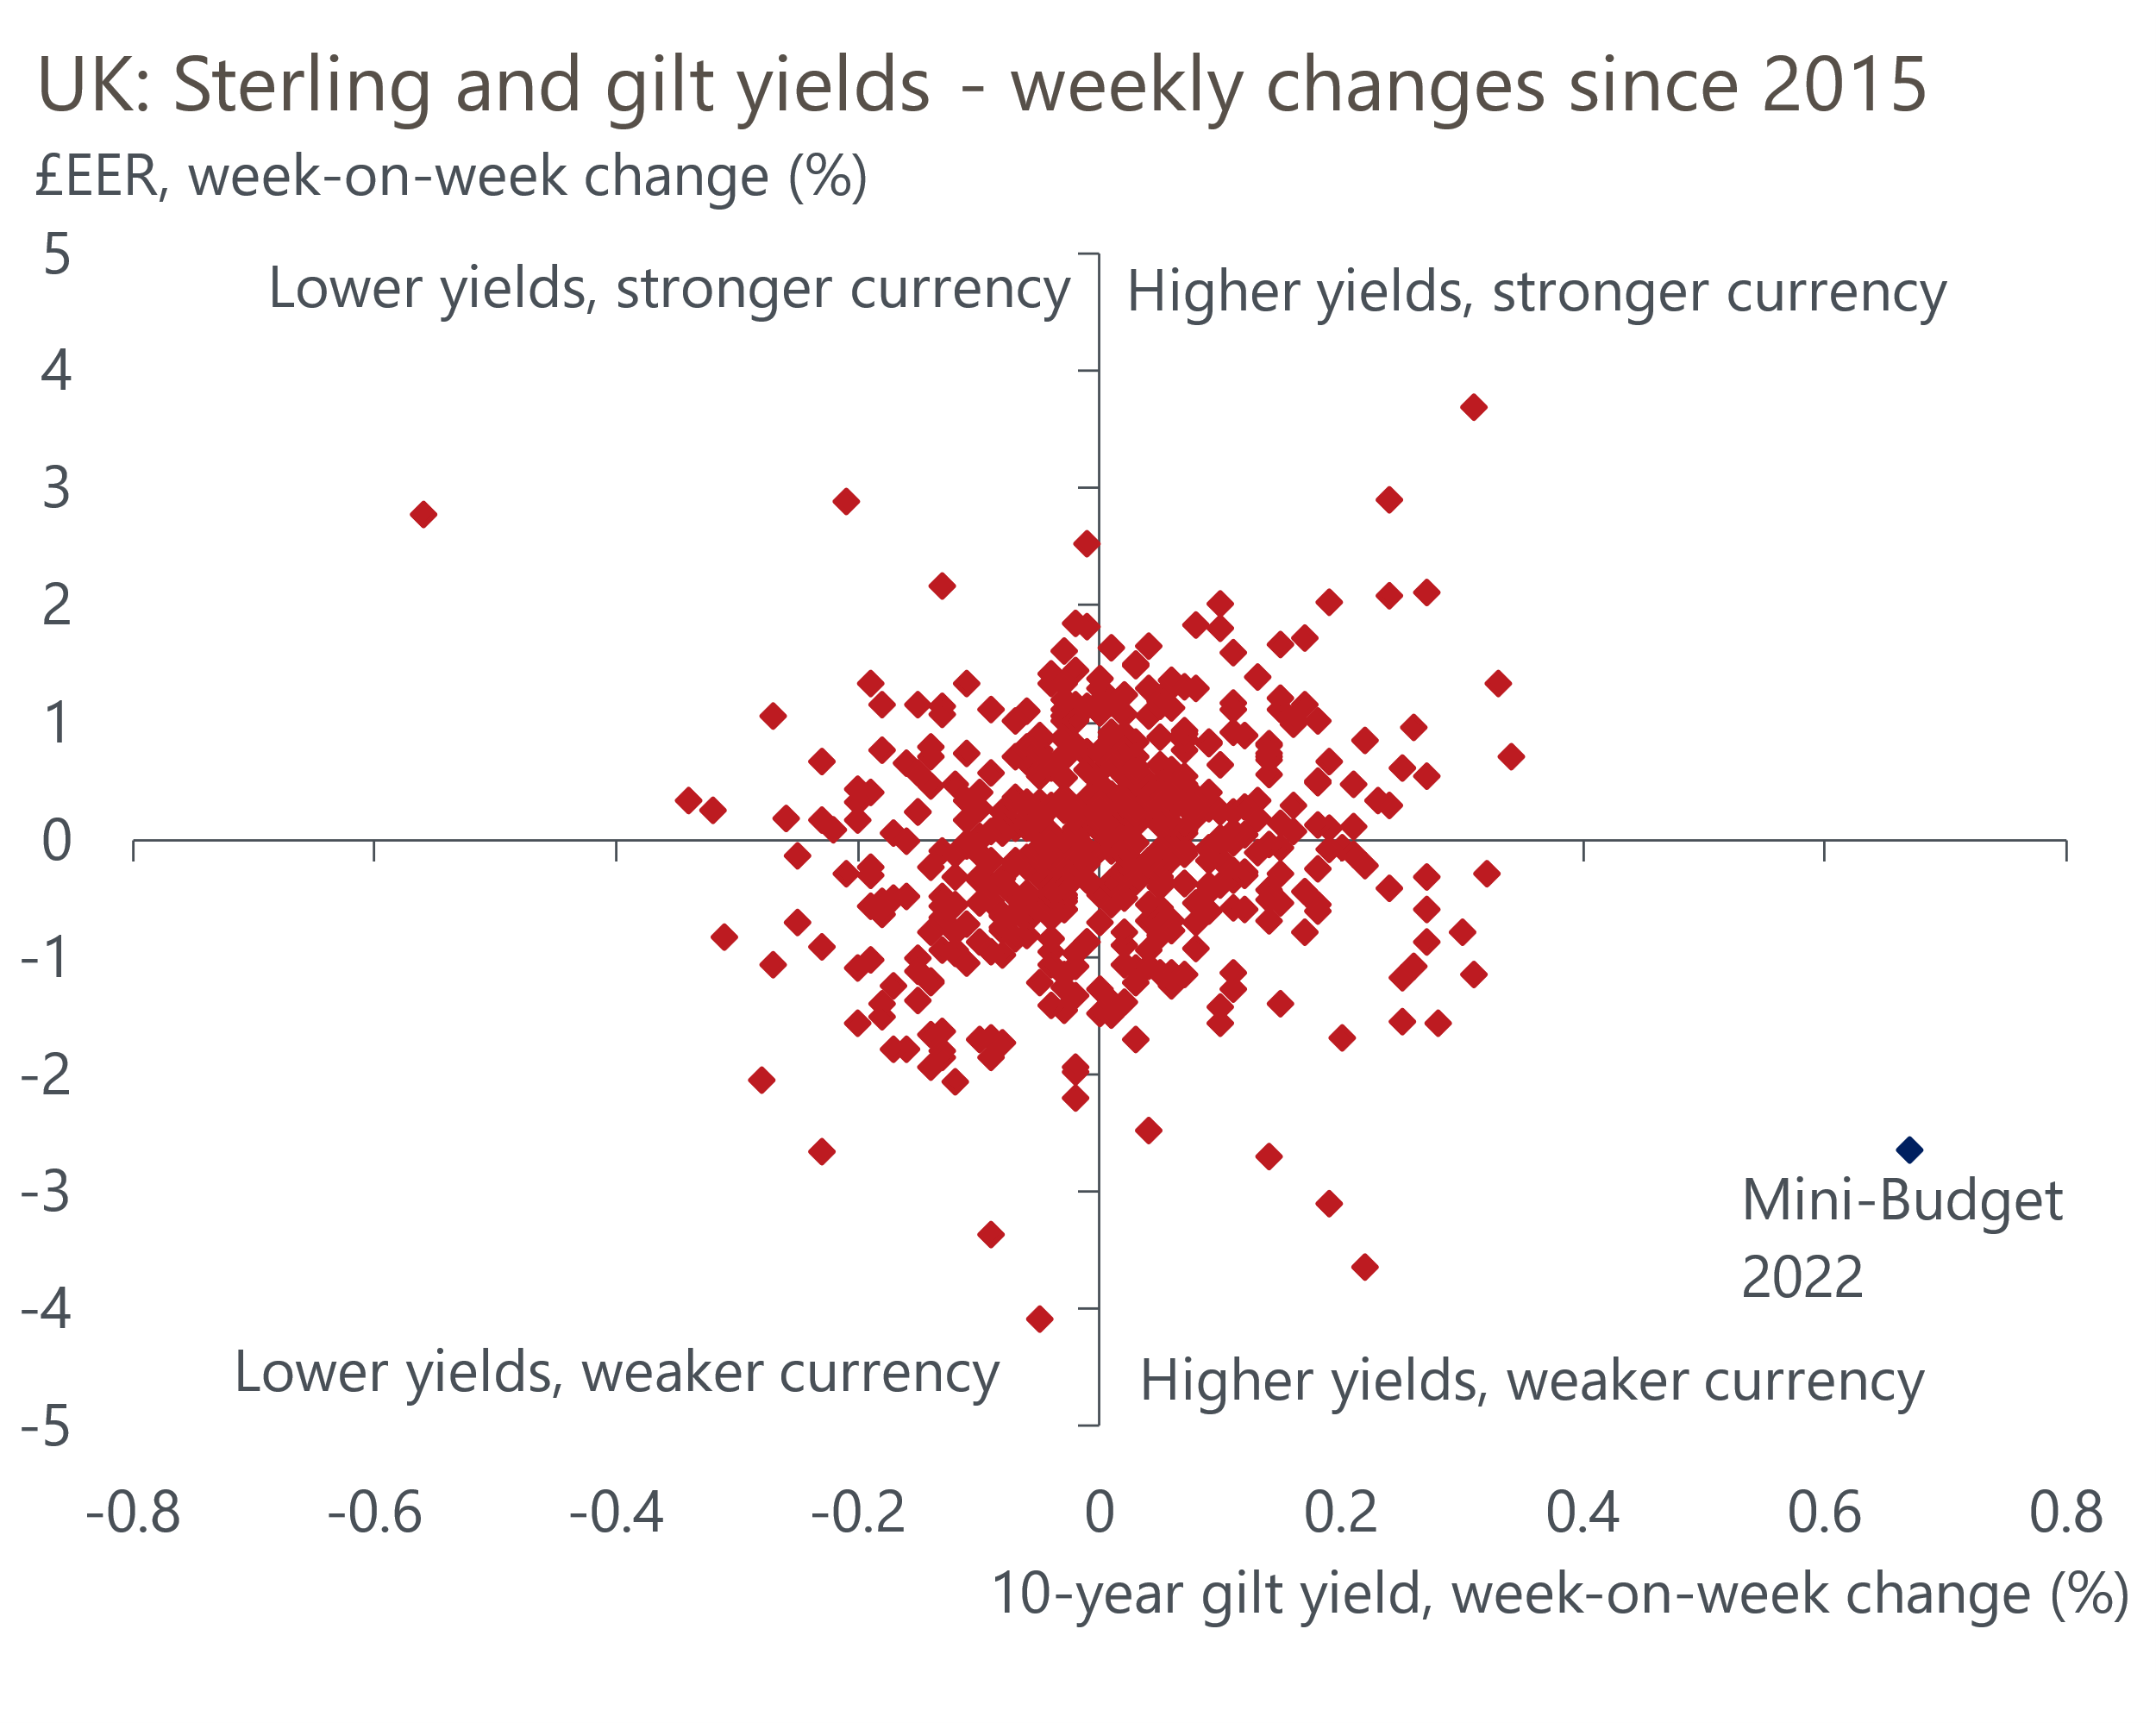
Sources: Oxford Economics, Haver Analytics

Currency risk may not be top of the list, but should be kept in mind
Ultimately, there are much bigger forces than the currency that will determine the UK outlook over the coming years. But it has the scope to make an already difficult situation worse if sterling's potential fragility is disregarded. A sharp deterioration in the currency could pressure fiscal policymakers to tighten policy further in a bid to convince markets that they're serious about keeping the public finances on a sustainable footing. That would have a more material impact on the outlook.

